**Task 1**

**Name: Ateeq Ur Rehman**

**Subject: OOP**

**ID: 221475**

**Question No 1**

**Solutions:**

**Input:**

#include<iostream>

#include<conio.h>

using namespace std;

class student

{

int id, marks;

float cgpa;

public:

// Constructor

student()

{

id=0;

marks=0;

cgpa=0;

}

// Set functions

void set_id()

{

cout<<"Enter the id of the student"<<endl;

cin>>id;

}

void set_marks()

{

cout<<"Enter the marks of the student"<<endl;

cin>>marks;

}

void set_cgpa()

{

cout<<"Enter the cgpa of the student"<<endl;

cin>>cgpa;

}

// Get Functions

int get_id()

{

return id;

}

int get_marks()

{

return marks;

}

float get_cgpa()

{

return cgpa;

}

};// class of student

int main()

{

// Creating the object

student data;

// Calling the functions

data.set_id();

data.set_marks();

data.set_cgpa();

// Displaying the data

cout<<"ID: "<<data.get_id()<<endl;

cout<<"Marks: "<<data.get_marks()<<endl;

cout<<"CGPA: "<<data.get_cgpa()<<endl;

getch();

return 0;

}// main

**Output:**

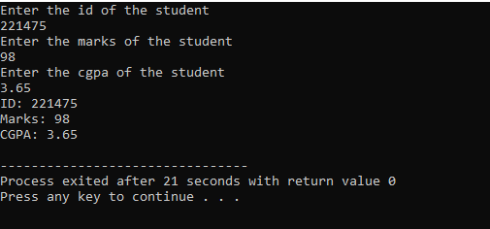

**Question No 2**

**Solution:**

**Input:**

#include<iostream>

#include<conio.h>

using namespace std;

class student

{

int id, marks[5], sum, i;

float cgpa;

float average;

public:

// Constructor

student()

{

id=0;

cgpa=0;

sum=0;

average=0;

i=0;

}

// Set functions

void set_id()

{

cout<<"Enter the id of the student"<<endl;

cin>>id;

}

void set_marks()

{

for(int i=0; i<5; i++)

{

cout<<"Enter the subject "<<i+1<<" "<<endl;

cin>>marks[i];

}

}

// Get functions

int get_id()

{

return id;

}

float get_average()

{

for(int i=0; i<5; i++)

{

sum=sum+marks[i];

}

average=sum/5.0;

return average;

}

};// class of student

int main()

{

// Creating the object

student data;

// Calling the functions

data.set_id();

data.set_marks();

// Displaying the data

cout<<"ID: "<<data.get_id()<<endl;

cout<<"Average is "<<data.get_average()<<endl;

// Pass/ fail logic

if(data.get_average()<=50)

{

cout<<"You are Fail"<<endl;

}

if(data.get_average()>50)

{

cout<<"You are Pass"<<endl;

}

getch();

return 0;

}// main

**Output:**

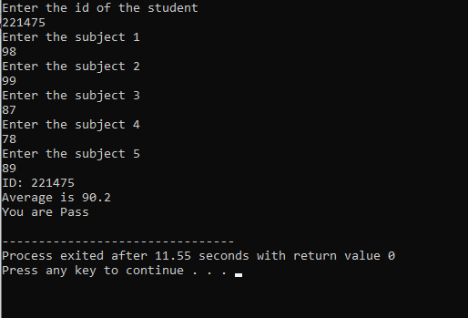

**Question No 3**

**Solution**

**Input:**

#include<iostream>

#include<conio.h>

#include<iomanip>

using namespace std;

class student

{

int id, *marks, sum, i;

float average, size;

public:

// Constructor

student()

{

id=0;

sum=0;

average=0;

i=0;

}

// Set functions

void set_id()

{

cout<<"Enter the id of the student"<<endl;

cin>>id;

}

void set_marks()

{

for(int i=0; i<size; i++)

{

cout<<"Enter the subject "<<i+1<<" "<<endl;

cin>>marks[i];

}

}

void choice()

{

cout<<"How many subject marks do you enter"<<endl;

cin>>size;

marks=new int(size);

}

void pass_fail()

{

if(average<=50)

{

cout<<"\t You are Fail"<<endl;

}

if(average>50)

{

cout<<"\t You are Pass"<<endl;

}

}

// Get functions

int get_id()

{

return id;

}

float get_average()

{

for(int i=0; i<5; i++)

{

sum=sum+marks[i];

}

average=sum/size;

return average;

}

};// class of student

int main()

{

// Creating objects

student data;

// Calling the function

data.set_id();

data.choice();

data.set_marks();

// Displaying the data

cout<<endl;

cout<<"\n\t Data"<<endl;

cout<<"\n\t ID: "<<data.get_id()<<endl;

cout<<fixed<<showpoint<<setprecision(2);

cout<<"\t Average is "<<data.get_average()<<endl;

data.pass_fail();

getch();

return 0;

}// main

**Output:**

